Numeracy | Out and About! | Literacy
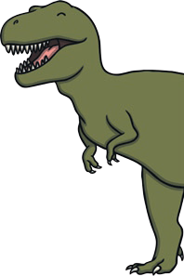  - Some T. rexes were 6 metres tall. Measure your family with a tape measure and write down their heights in order.  - Create some dinosaur word problems (e.g. If one dinosaur has 4 legs, how many legs do 3 dinosaurs have?)  - Draw a picture of a dinosaur, using only 2D shapes.  - Create a table with the headings Carnivore and Herbivore. Try to add as many dinosaurs under each heading as you can. |     - Visit your local library and find some non-fiction books about dinosaurs.  - Research and find on a map countries where interesting fossils have been found. | - Imagine you have been on a fossil hunt. Write a diary entry about your adventure.  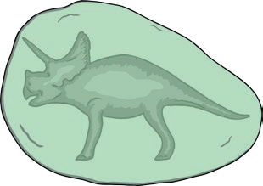  - Choose a dinosaur and create a fact file, book, or poster all about them.  - Write 10 adjectives (describing words) about your choice of dinosaur.  - Write a dinosaur-themed  poem or story.
Working with Others | Homework Choice Grid  Dinosaurs  Please choose at least 3 activities from the grid to complete by 23rd March 2020.  Any photos can be sent to  g.roberts@sjsm.lancs.sch.uk | Expressive Arts
- With a friend or family member, make up a Dinosaur Alphabet. Make a list naming at least one dinosaur for every letter in the alphabet.    - Find or write some dinosaur jokes and share them with friends or family members! |  | 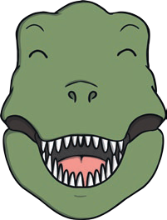  - Think about where dinosaurs lived.  Create a shoebox habitat!  - Create your own dinosaur. Draw and label it.  - Design a dinosaur mask.  - Create a dinosaur picture using paint, pens, pencils, or your choice of materials.  - Write a dinosaur rap or song.
Let’s Get Technical! | Health and Wellbeing | Research
    - Make a 3D junk  model dinosaur.  - Use a computer to draw a picture of a dinosaur.  - Use a computer to research facts about the Jurassic period. |   - Create a list of foods a herbivore dinosaur might eat if they were alive today.  - Create a list of foods a carnivore dinosaur might eat if they were alive today.  - Create a Dinosaur Menu. Be as creative as you can! |   - Find out which dinosaur was the smallest/tallest/fastest/heaviest.  - Choose a dinosaur and write  five fascinating facts.  - Can you create a timeline from the Triassic period up until dinosaurs  became extinct?

